TASK 6

- use sql_db1;
SELECT * FROM sales_data1 ;
select order_date from sales_data1 ;
select order_date
, month(order_date) as Month
,year(order_date) as Year
from sales_data1;
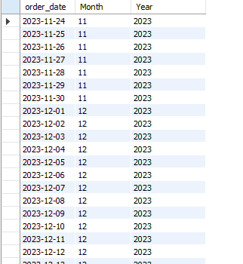

- SELECT COUNT(product_id), product_category
FROM sales_data1
GROUP BY product_category;

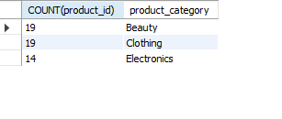
- SELECT sum(amount)
FROM sales_data1

WHERE year(order_date) = 2023;
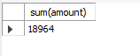

- SELECT count(product_id)
FROM sales_data1
where amount > 500;
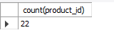

- select * from sales_data1 order by product_category;

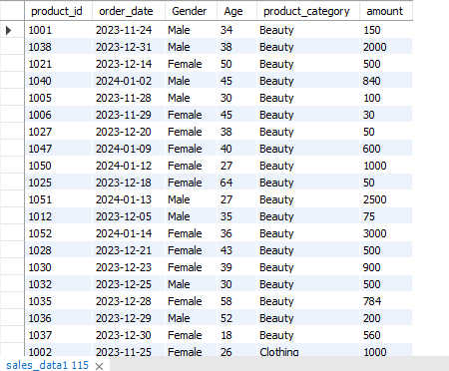

- SELECT * FROM sales_data1
WHERE product_category='Clothing'
LIMIT 10;

